 Department of Chemistry and Physics
CP 2700-Wave Motion
Exploratory Task
Name ______________________________
Part (I)
Investigating the Doppler Effect
https://www.compadre.org/osp/items/detail.cfm?ID=12399&Attached=1
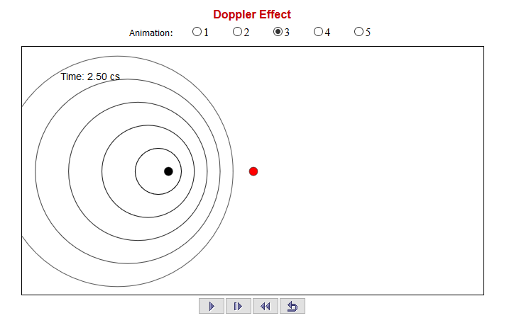

Simulation Questions:
- Click the play button to see a stationary source and receiver (Animation 1). Reset and use the pause and step buttons to verify that the period at the receiver (time elapsed from when one wave reaches the receiver until the next one reaches it) is 5.0 × 10⁻³ s. What is the frequency of this wave?

- After there are several waves in the simulation pause it and use the mouse to find the wavelength (distance between two successive crests). What are the wavelength and speed of the wave (wavelength/period)?

- Now look at Animation 2, where the receiver is moving. Use the step button above to find the period (time between crests) as measured by the moving receiver when it is on the right of the source (moving towards the source). What is the frequency at the receiver if it is moving towards the source?

- When the receiver gets to the left of the source (moving away from the source) pause the simulation and measure the period. What is the frequency at the receiver if it is moving away from the source?

- Now look at Animation 3 which shows the source moving but the receiver stationary. Again find the frequency while the source is on the left, moving towards the receiver and the frequency when it is on the right moving away.

Part (II)
Using the Doppler Effect to determine the Speed of a Moving Object
Doppler Effect Formula for General Cases
- The source and the observer could both be in motion; the observed frequency f₀ is given by the equation
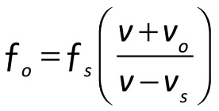
Where f_{s} is the frequency of the source, v is the speed of the signal, v_{o} is the speed of the object, and v_{s} is the speed of the source.
If either one is approaching we use positive values for v_{o} and v_{s}.
If either one is moving away (receding) from the other we use negative values for v_{o} and v_{s}.

Background Example
An alert student stands beside the tracks as a train rolls slowly past. The student notes that the frequency of the train whistle is 480 Hz when the train is approaching, and 440 Hz when it is moving away (receding). Using these frequencies the train’s speed can be calculated.
Using
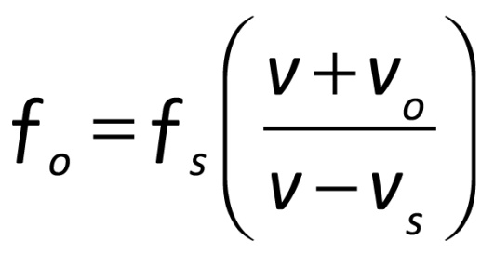
V₀ = 0 (the observer is at rest)
Vs =Vt (the speed of the source is that of the train)
V = 340 m/sec for the speed of sound
Approaching: 480 Hz = f_{s} ($\frac{ 340 m/sec}{340 m/\sec{- Vt}}$).
Receding: 440 Hz = f_{s} ($\frac{ 340 m/sec}{340 m/\sec{+ Vt}}$).
Dividing the first equation by the second:
$\frac{480 Hz}{440 Hz}$ = $\frac{fs (\frac{ 340 m/sec}{340 m/\sec{- Vt}})}{fs (\frac{ 340 m/sec}{340 m/\sec{+ Vt}})}$ = 1.09 (The f_{s} and 340 m/sec terms drop out)
Inverting the right side of the equation
1.09 = ($\frac{340 m/\sec{+ Vt}}{340 m/\sec{-Vt}}$), cross-multiplying
(1.09) (340 m/sec – Vt) = 340 m/sec + Vt
370.6 m/sec – (1.09) Vt = 340 m/sec + Vt, rearranging the equation
370.6 m/sec – 340 m/sec = Vt + (1.09) Vt
Vt (1 + 1.09) = 30.6 m/sec
Vt (2.09) = 30.6 m/sec
Vt = $\frac{30.6 m/sec}{2.09}$ = 14.6 m/sec is the speed of the train.
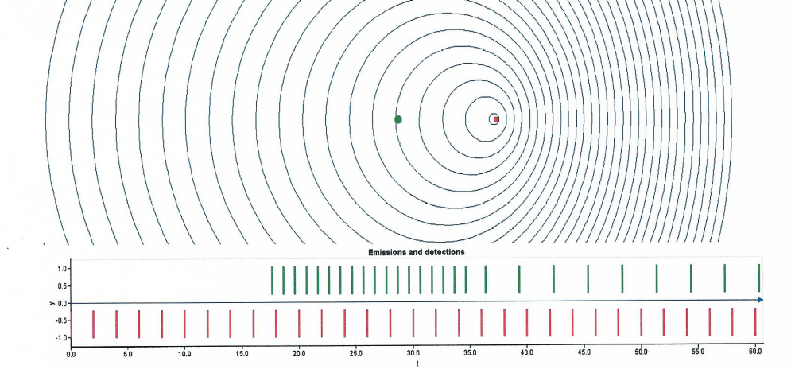

Doppler shift of sound waves emitted by a source indicated by the arrow, as it moves to the right. As the waves reach the observer indicated by the dot to the right of the source, the spacing of the lines demonstrate that the frequencies are unequal. In the top part the observer measures a higher frequency (lines are closer to each other) as the source approaches it. In the bottom part the frequency measured by the observer is initially higher, and then lower after the source has passed it (the lines are more closely spaced and then further apart). However, the frequency of the source remains constant (lower scale in both parts).

(Procedure to be done as a demonstration)

